Mushroom Cultivation

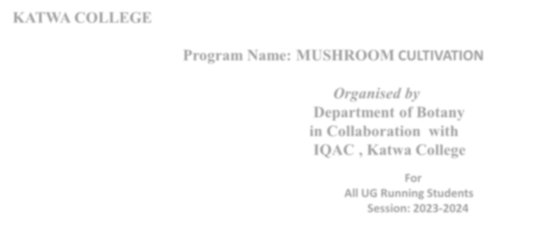

**KATWA COLLEGE**

**Program Name:**

**MUSHROOM**

**CULTIVATION**

***Organised by***

**Department of Botany**

**in Collaboration with**

**IQAC, Katwa College**

**For**

**All UG Runni**

**ng Students**

**Sess**

**ion: 2023**

**-**

**2024**

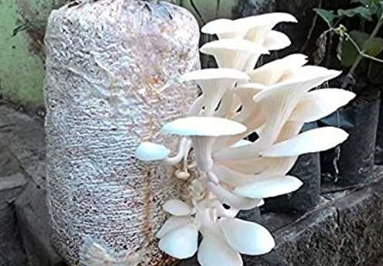

***ADD***

***-***

***ON***

***COURSE***

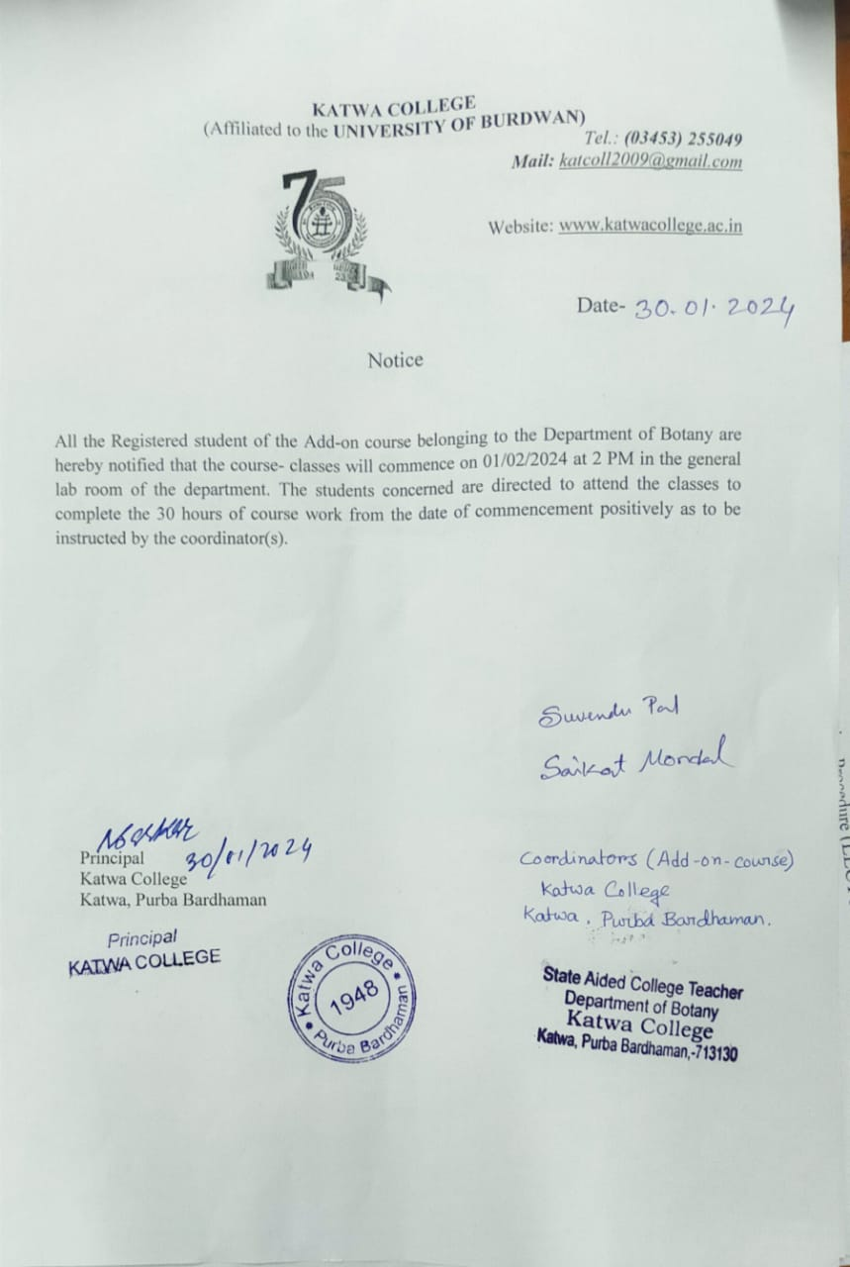

**SYLLABUS DETAILS**

UNIT 1: Introduction (LECTURES 2)

UNIT 2: cultivation Procedure (LECTURES 15)

UNIT 3: Storage and Nutrition (LECTURES 5)

UNIT 4: Food preparation (LECTURES 6)

UNIT 5: Future aspects (LECTURES 2)

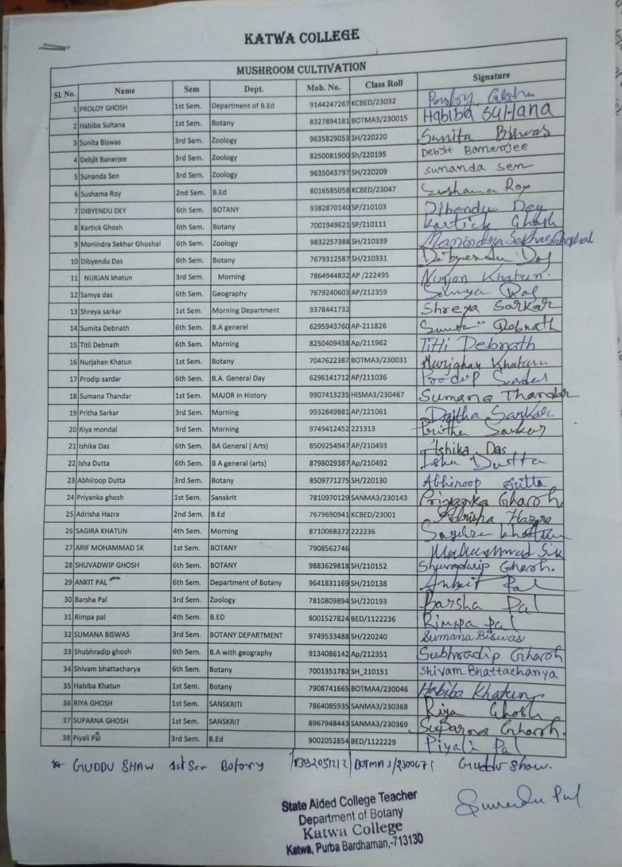

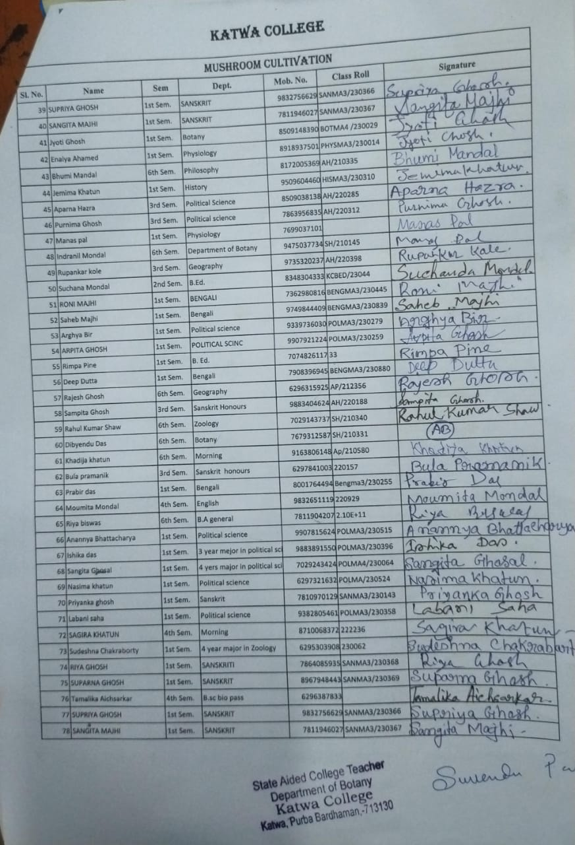

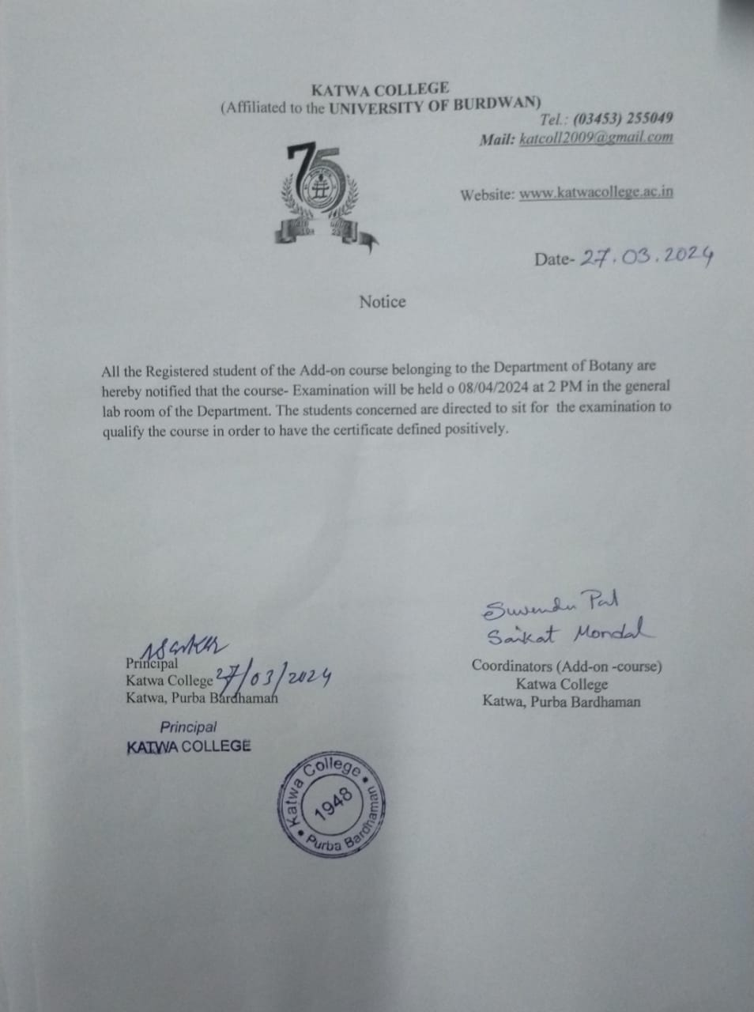

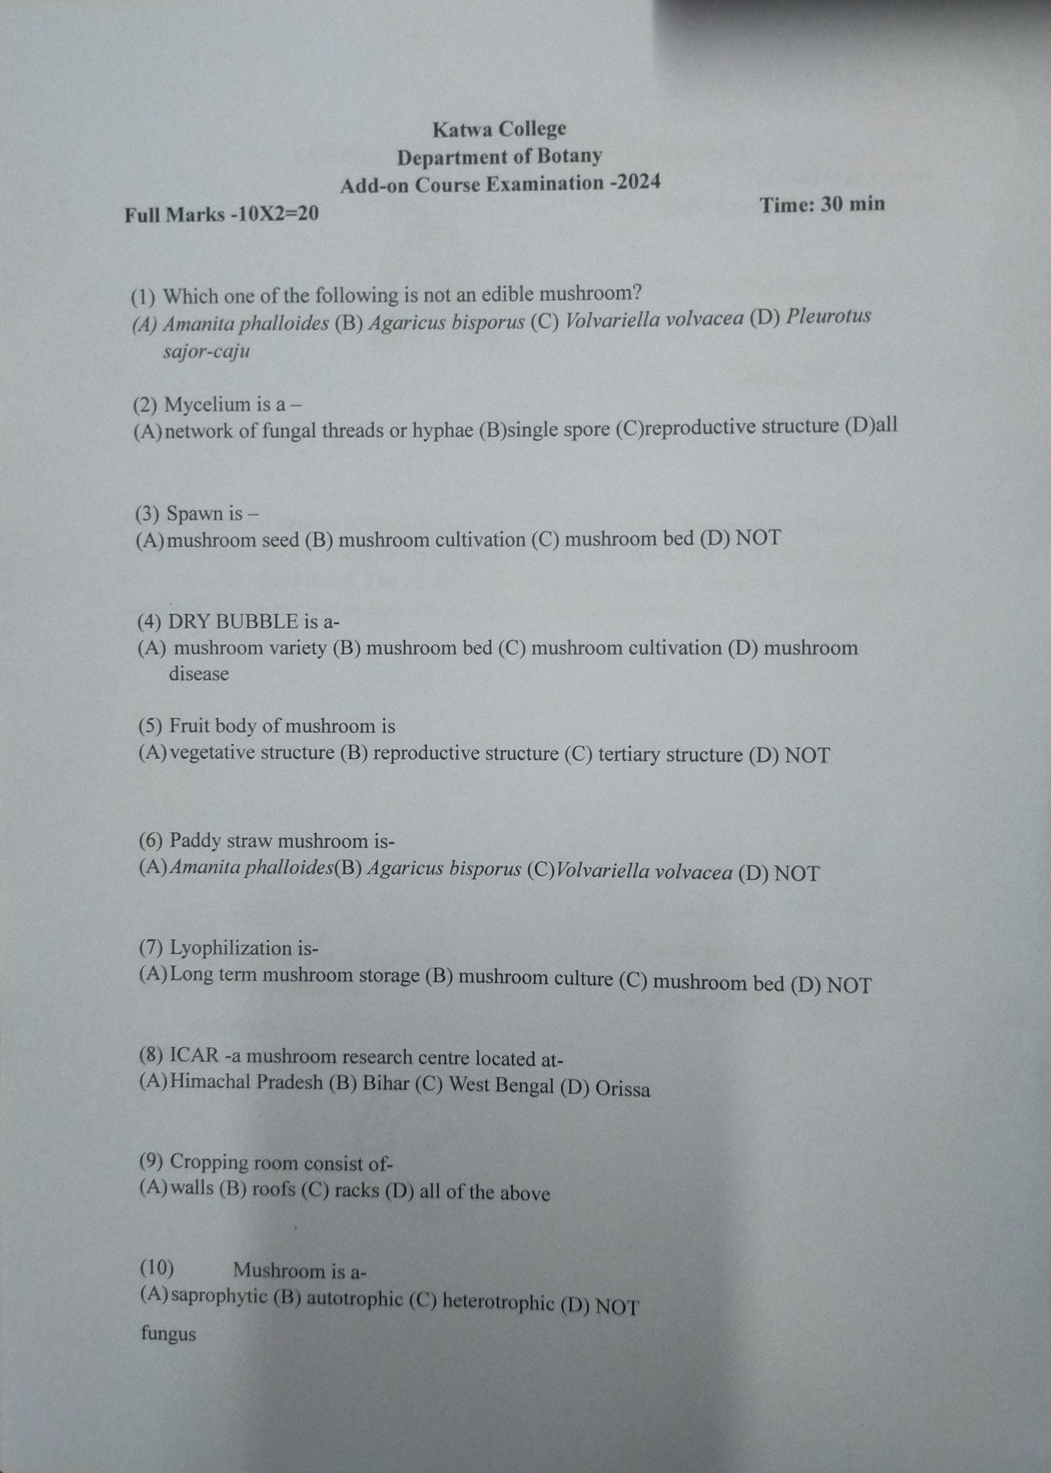

**Report of Add on course**

1. **Name of the course**: Mushroom Cultivation
2. **Department offering this course:** Botany
3. **Date of commencement:** 01/02/2024
4. **Name of the Course coordinator:** Mr. Suvendu Pal & Mr. Saikat Mondal
5. **Hours of Learning:** 30 hours

6. **Objectives of the course:** Mushroom cultivation with the objective of large-scale production and its marketing for an alternative source of income.

7.**Course outcome:** The course was started on 01/02/2024.As many as 78 student-participants, belonging to different disciplines were present in the course. A brief idea about the nutritional value and market demand of mushroom were discussed in the course (theory) class. Preparations of mushroom bed, collection of spawns, cultivation and long-term storage of mushroom were discussed elaborately and demonstrated as far as practicably in the practical laboratory. Then practical class started and mushroom bed were prepared with the help of the student-participants. In the process the cultivated mushrooms were observed carefully to detect out of the infected ones and they were removed from the bed. After certain period of time all the fresh mushroom were collected from the bed and shown to the students that roused enthusiasm. Packaging process were discussed and demonstrated in the classroom in the next stage. Students learnt the whole process clearly. Some of them tried the procedure at their homes and got very good result. It was a grand success, I think.

**6. Course syllabus:** UNIT 1: Introduction (LECTURES 2)

UNIT 2: cultivation Procedure (LECTURES 15)

UNIT 3: Storage and Nutrition (LECTURES 5)

UNIT 4: Food preparation (LECTURES 6)

UNIT 5: Future aspects (LECTURES 2)

1. **Course module:**

|  |  |  |  |  |
| --- | --- | --- | --- | --- |
| Sl no | Course title | Theory (Hours) | Practical (Hours) | Teachers name |
| 1 | Introduction | 2 | 0 | Suvendu Pal |
| 2 | Cultivation Procedure | 2 | 4 | Suvendu Pal & Saikat Mondal |
| 3 | Cultivation Procedure | 2 | 4 | Saikat Mondal & Suvendu Pal |
| 4 | Cultivation Procedure | 1 | 2 | Saikat Mondal & Suvendu Pal |
| 5 | Storage and Nutrition | 2 | 3 | Saikat Mondal & Suvendu Pal |
| 6 | Food preparation | 2 | 0 | Saikat Mondal |
| 7 | Food preparation | 4 | 0 | Suvendu Pal |
| 8 | Future aspects | 2 | 0 | Saikat Mondal & Suvendu Pal |

